Van Gogh’s GARBAGE Hunt

Category: OSINT

Type: static

Author: este_n

Image provided:

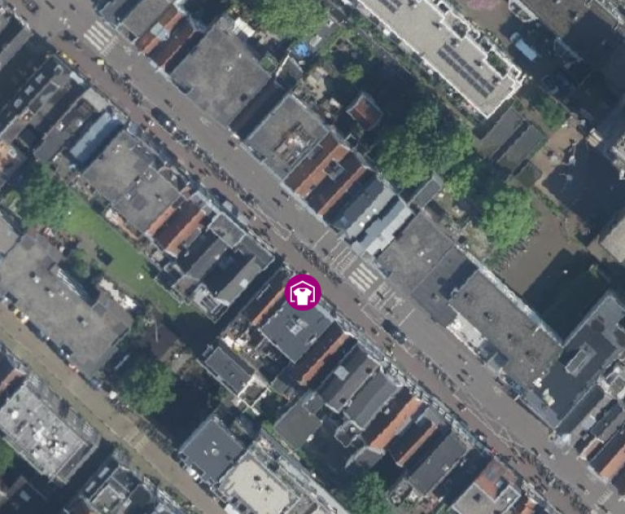

Breakdown:

* The provided image, when put on Google Image search, gives the location of Amsterdam.
* The words in capital, GARBAGE MAP, prompt the player to search for Amsterdam’s [garbage map](https://kaart.amsterdam.nl/afvalcontainers?pk_vid=8e785651efe4d2c1173807197508ddb5#52.3525/4.7365/52.4201/5.0002/brt/13698//5453783@13698).
* On opening the map, they’ll see a number of categories. On selecting “textile collection point”, only three such places show up.
* The players can now approach it on trial-and-error basis.
* pearl{the_swap_shop}.